Jahaziel Ramirez

CIS233DA

Before you come to class

A.) Screenshot of filing system

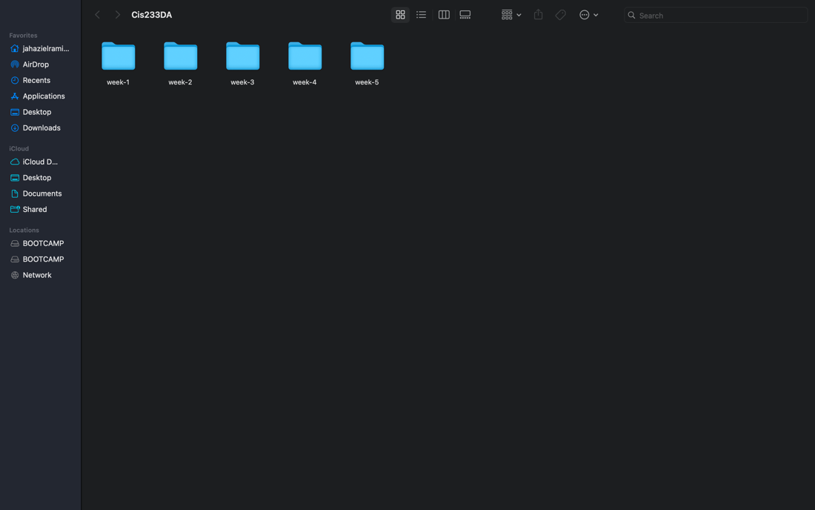

B.) Screenshot of Vscode

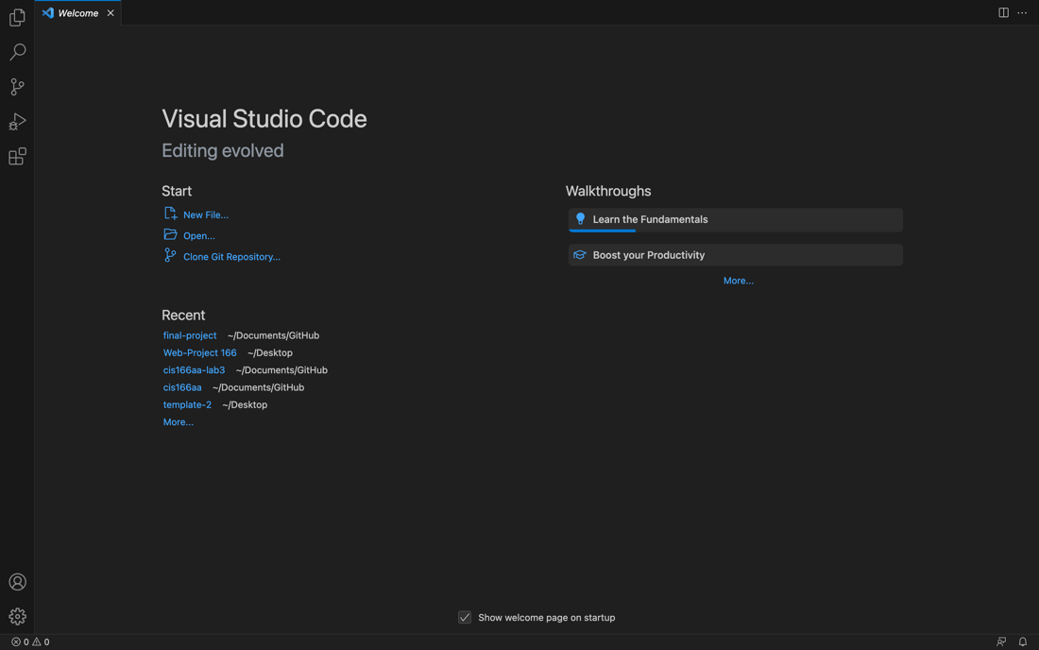

C.) URL of github repository

<https://github.com/Jahazielnrl/CIS-233DA.git>